Lab 2
Exercise 3
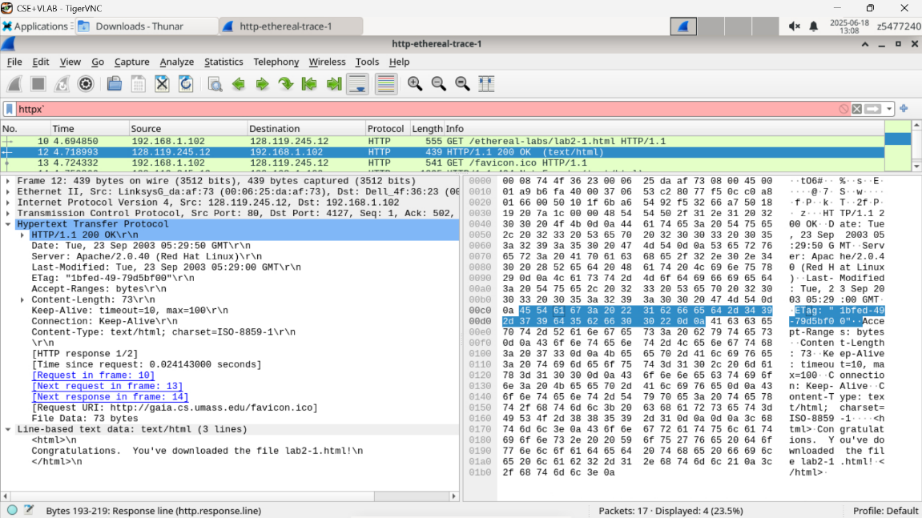
- Status code is 200 ok.
- The file was last modified was September 23rd 2003 05:29:00. The date given is September 23rd 2003 05:29:50 – and so it is likely that the server uses the date as last modified to conceal when the file was actually last modified.
- The connection is persistent since this is HTTP 1.1.
- The text is “Congratulations. You've downloaded the file lab2-1.html!\n”
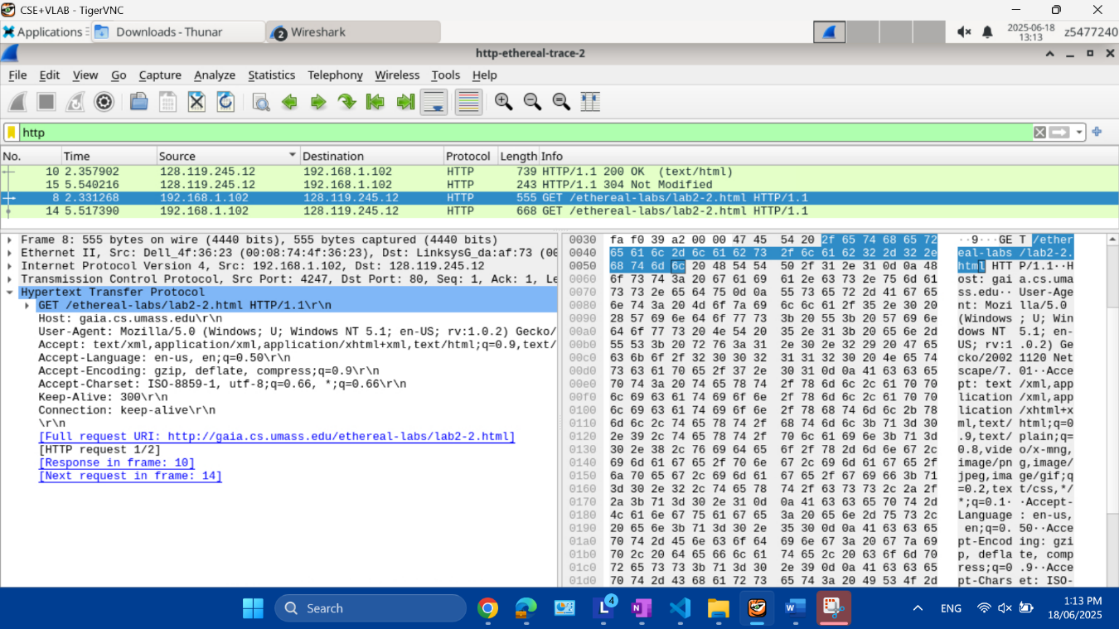
Exercise 4
- There is no last modified line – this is because this is the first time the browser requests the HTML.
- There is no IF-MODIFIED-SINCE field.

- Yes for both, the IF-MODIFIED-SINCE has the date that the initial response was created while the IF-NONE-MATCH has the etag of the first response.
- The HTTP code is 304 not modified – since the etag and the Last Modified is the same as the file on the server, that is the file has not changed, the server does not need to explicitly resend the file’s content.
- The etag between the first and second response are the same.
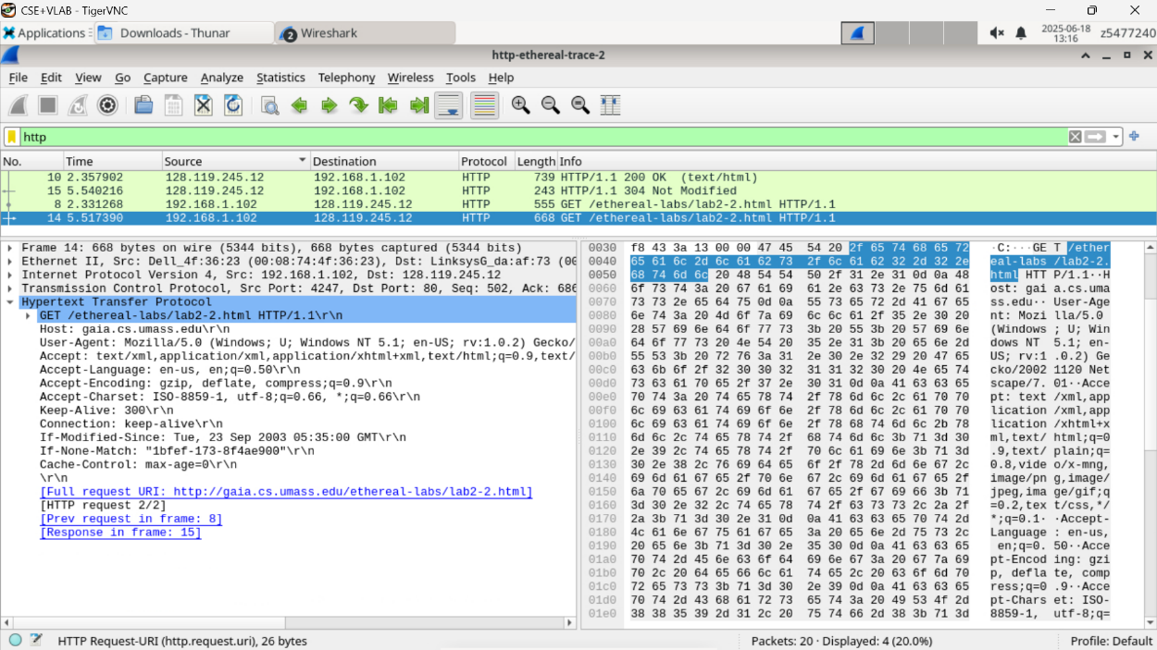
Exercise 5
